# Testing

## User testing

#### Devices

The family and kids were encouraged to test the live site on their devices. They found quite a few bugs which had to be fixed. Thanks kids!

|  |  |  |  |  |
| --- | --- | --- | --- | --- |
| **Device type** | **Model Name** | **Software Version** | **Landscape** | **Portrait** |
| **Phone** | iPhone7 | 14.2 |  |  |
|  | iPhone 8 |  |  |  |
|  | iPhone 5s |  |  |  |
| **MAC Book PRO** |  |  |  |  |
| **iPAD** |  |  |  |  |
| **PC** |  |  |  |  |

### Zoom testing

We tested the site on various browsers on the devices above. We used the zoom option on all devices to check that the site was responsive and adaptive!

### Landscape/Portrait testing

When turning an iPhone for example, the code adapted to the orientation.

### Accessibility testing

Form role=”form” allows someone with a screen reader to jump directly to the form by using the keyboard. It’s important for accessibility purposes.

Used labels for inputs – making it easier for someone with a disability to navigate through the form. Labeled and linked up with ID.

### Test Plan

Website testing was performed on the deployed site. It included testing of the following:

* Outgoing links
* Internal links
* Anchor links
* MailTo links
* Testing of forms – confirm default values work. Confirm submit works.
* Testing of the cookies – to check that 2 places where cookies are used.
* There were a number of issues to clear up with outgoing links – we had to go back and change the teamK website to “#” as we had no operating website to link to.
* The following shows the mailto testing:
* 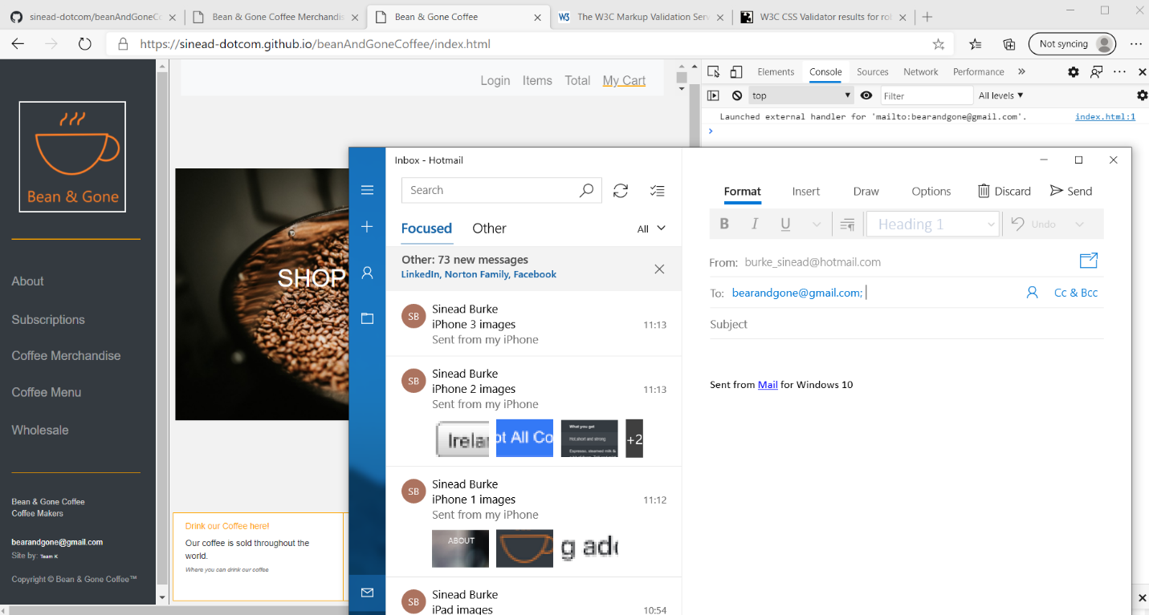
* There are 2 places on each page where this can be called. Tested all.

### Test Results

### Feedback from Test Results

## Functional testing

Besides the basic testing of all functionality on each page we tested external links.

Tested links to Twitter:

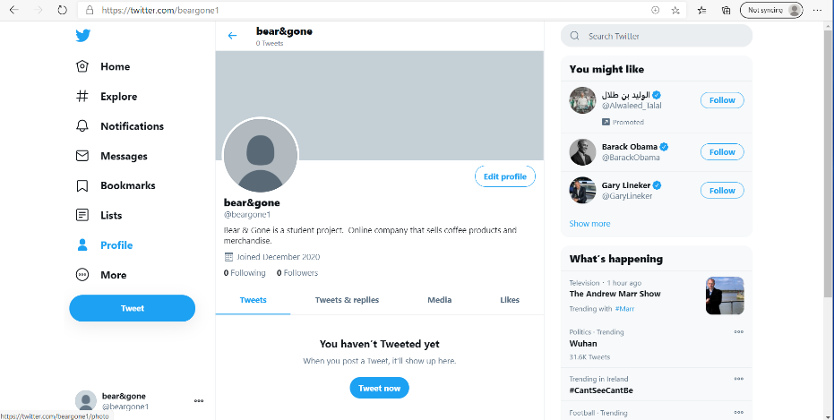

And tested the link to Facebook:

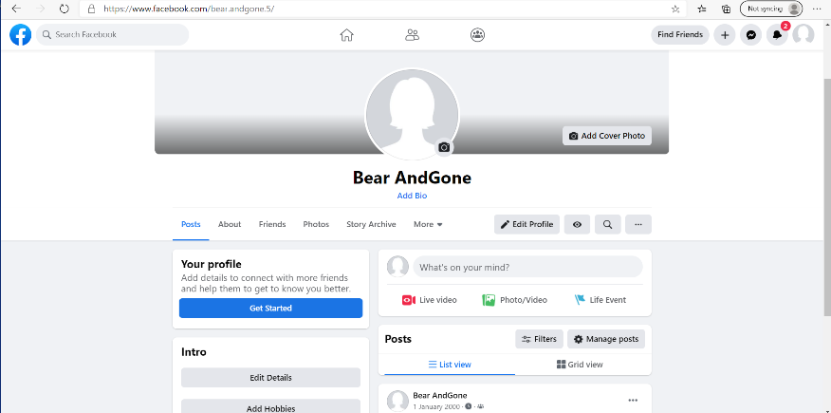

## Functional Cookie Testing

Testing of Cookies:

* The previous days cookies had disappeared – would like to retest this again as only did this test once
* On a browser with a LIVE site we tested the cookies. Starting from zero cookies.
* 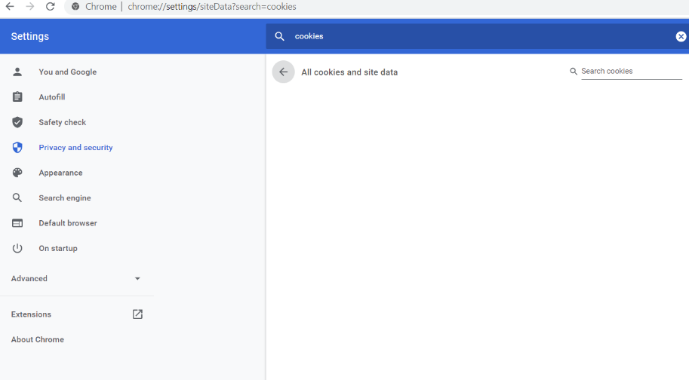

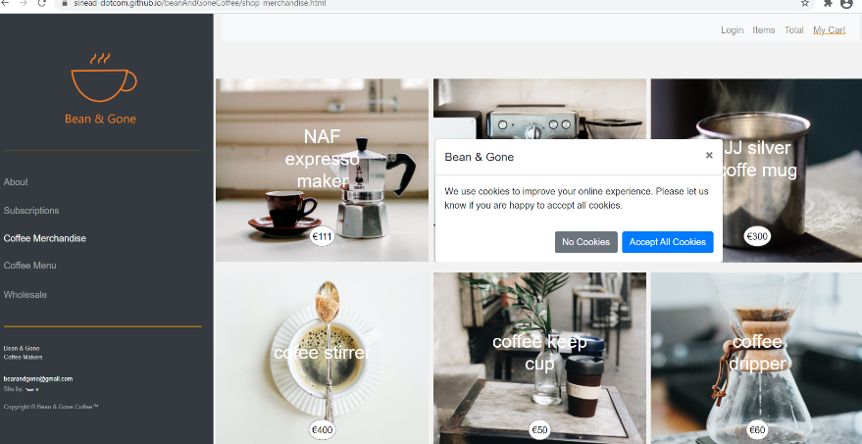

Firstly, we accept all cookies in this modal popup. We see that the cookie is seen and stored.

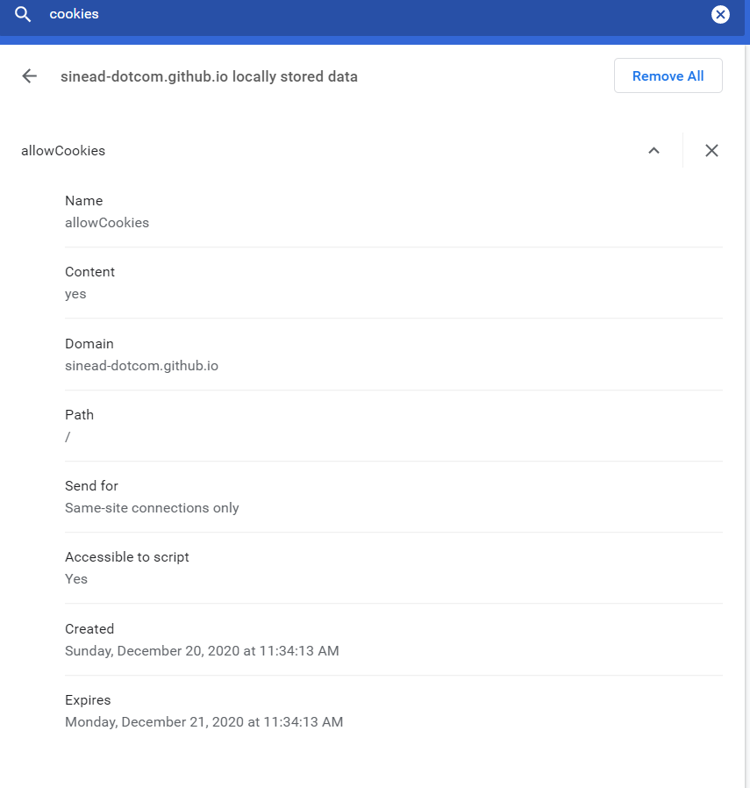

And the details of the cookie are: 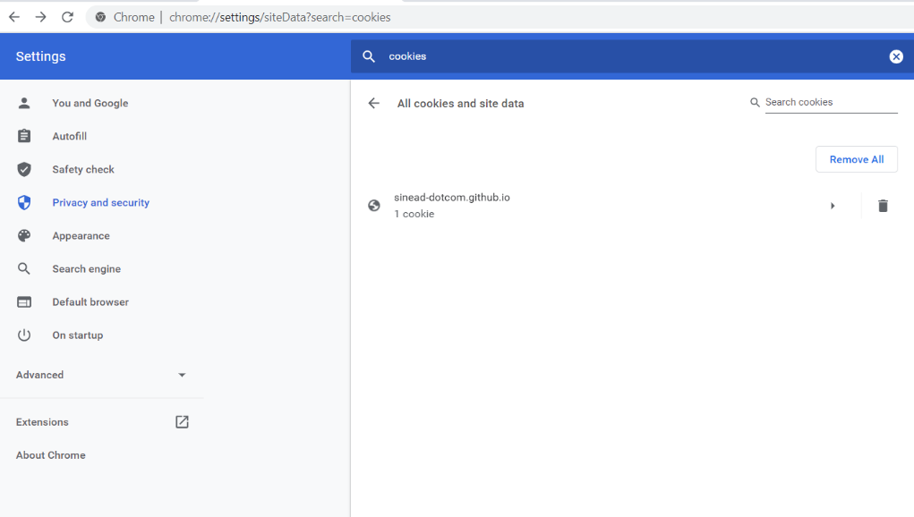

As you can see this is to identify that the user has agreed for cookies to be used/stored. Also, the expiry date is set correctly.

Next we choose a product, a cookie is used to store this chosen product. This means that when it clicks through to the product page that it knows which one to load.

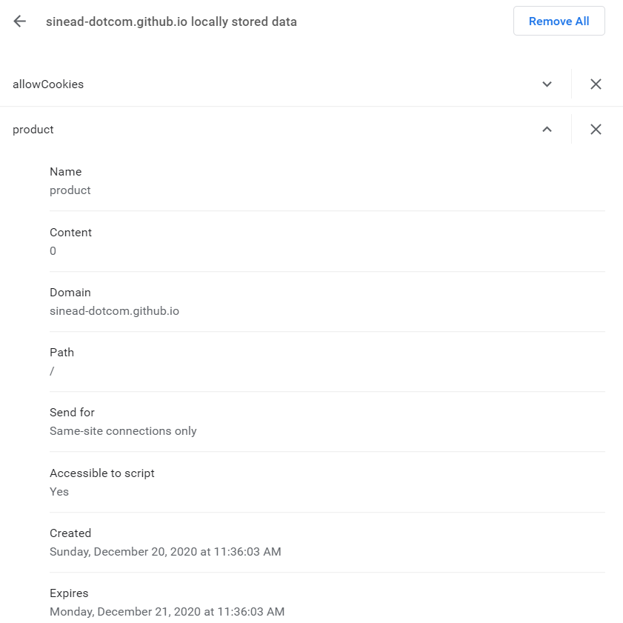

And, it also is stored for 1 day only.

Now that we have the correct product loaded. Lets add this product to the cart. Again a cookie is successfully stored to record this. This will help when I get the basket working.

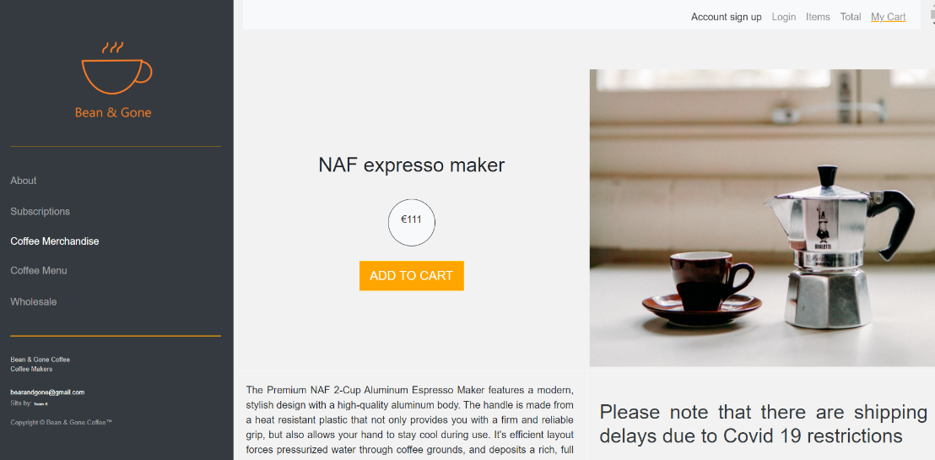

We now have 3 cookies.

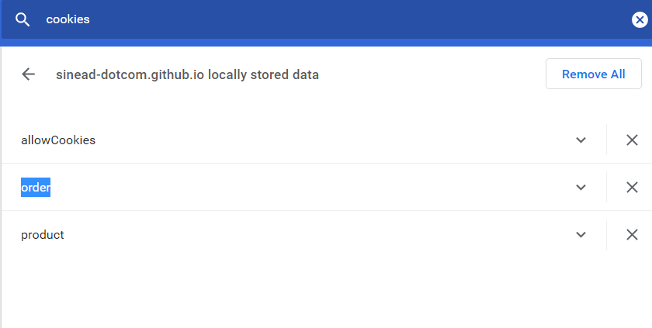

And this is the order cookie details – correctly set! Again this happened when the checkout button was clicked. I would like to show the addition of this item to the basket on the top NAV bar if there is enough time.

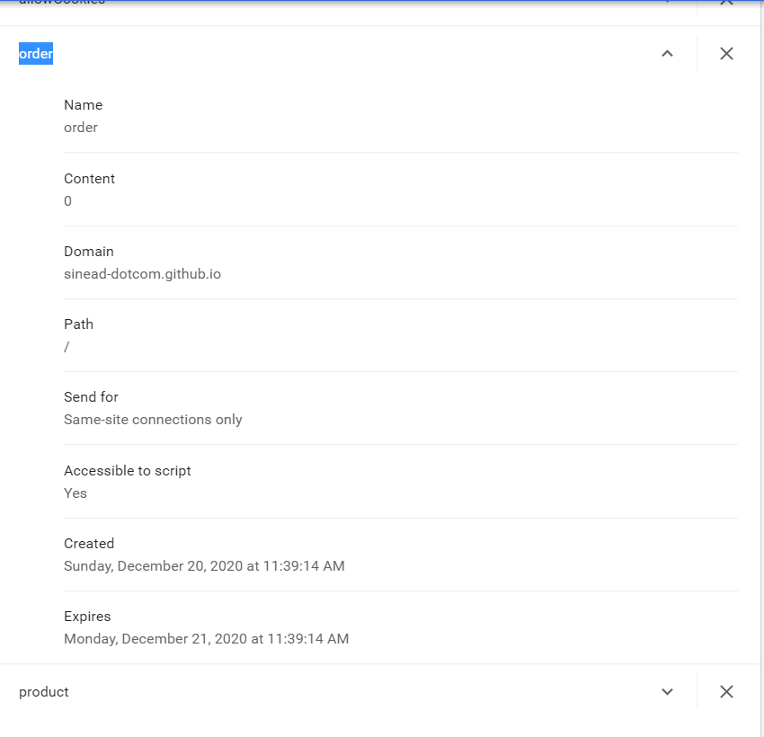

So, next test was to delete the cached cookies from the browser. Then reload the page and see what happens. The user was prompted to consent to cookies again – using the lovely bootstrap modal.

## Automated Testing

We did not do any automated testing. Many of the sites were looking for credit card numbers. 2 of the sites – when the software was installed did not work.

## HTML/CSS/Java testing

Project was W3C CSS & HTML compliant.

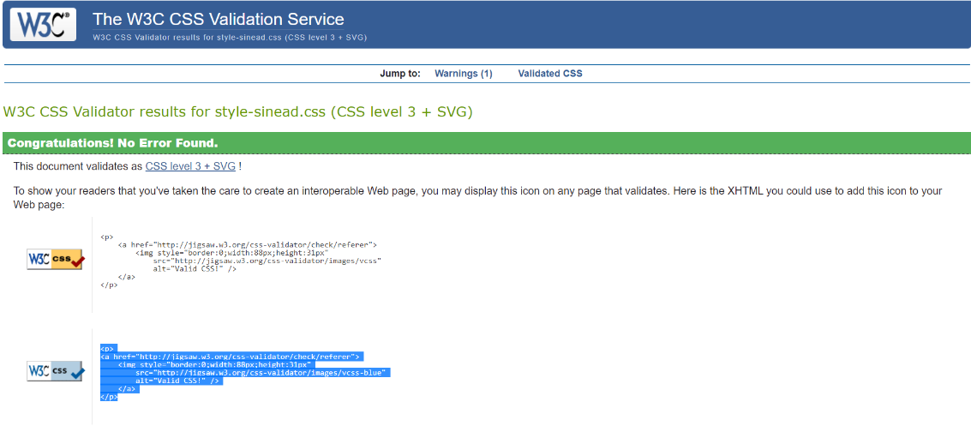

Optimisation of image file sizes. Looking through the image files some were rather large – with width (in pixels) greater than 5k – this explained the slow download time. As a first pass I went through all of the image files and made the maximum size around 1000 pixels wide. This made a huge difference.

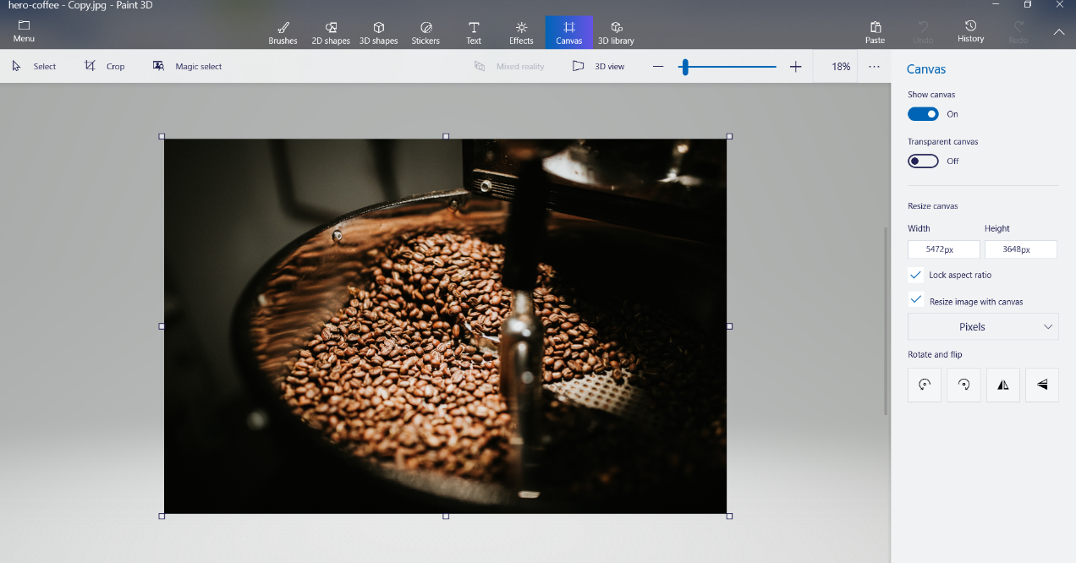

Decreased the file size to a much more reasonable value. We had a lot of images so this was significant. Luckily, it brough the KB down to below 200KB for each file! Big difference. It decreased the file above from over 3MB to 178KB – much better!

Some Validation Testing:

It was interesting to see that a warning was thrown for the following:

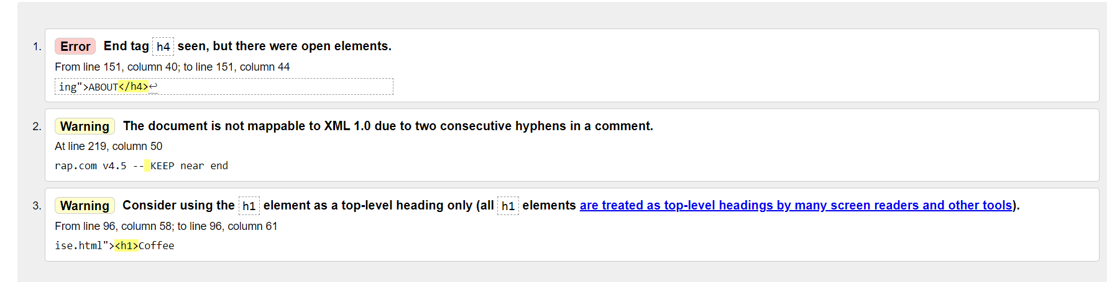

Warning 3 – it didn’t like the use of h1 in this place!

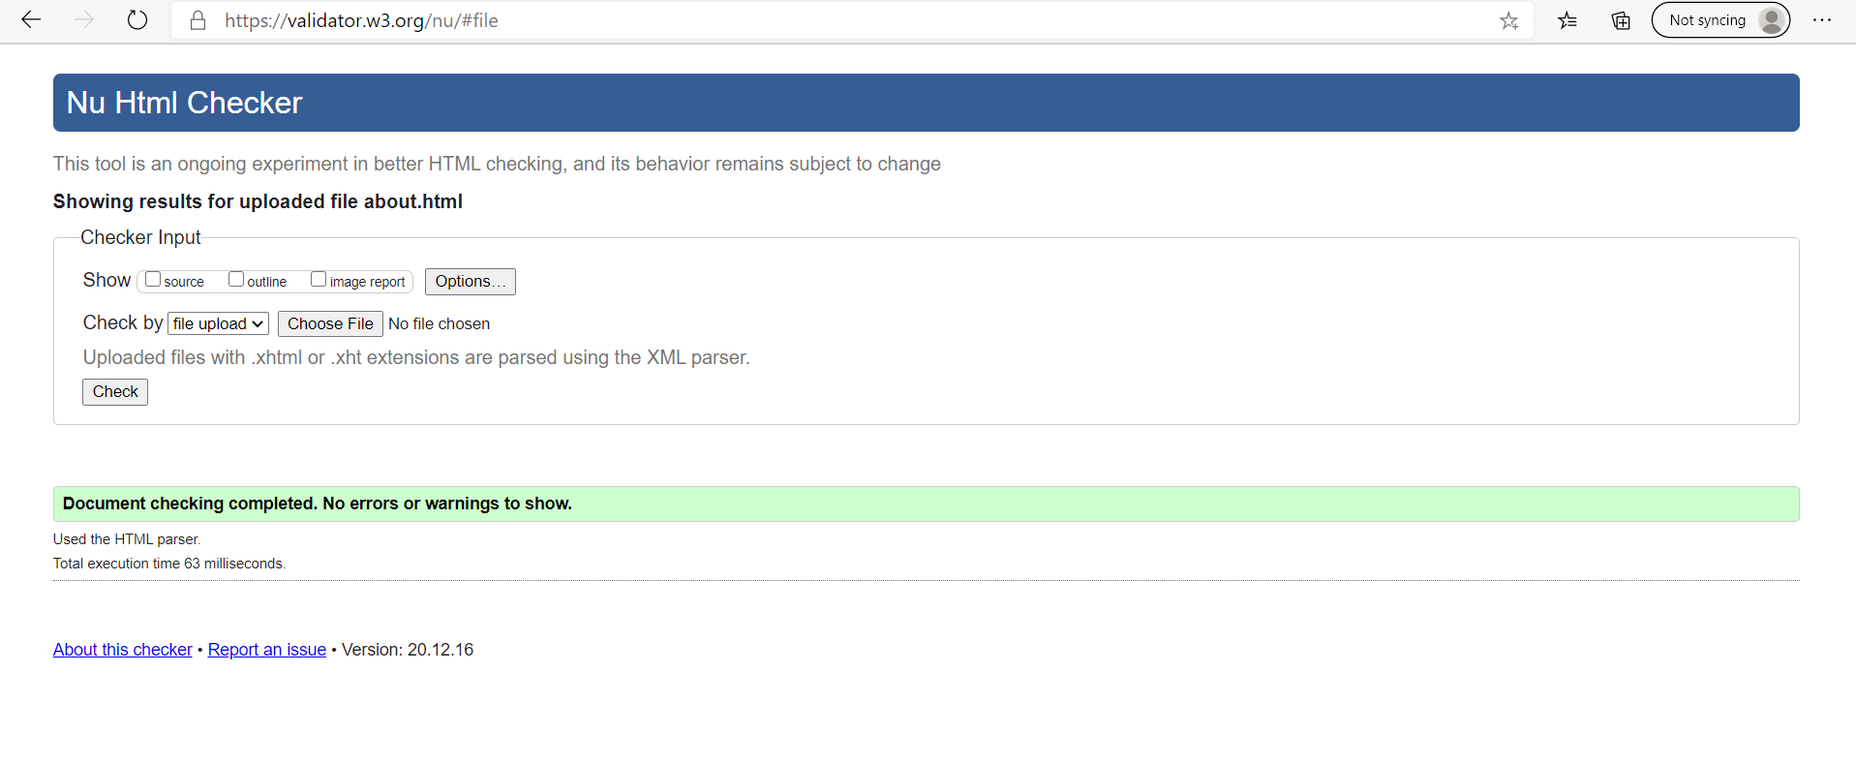

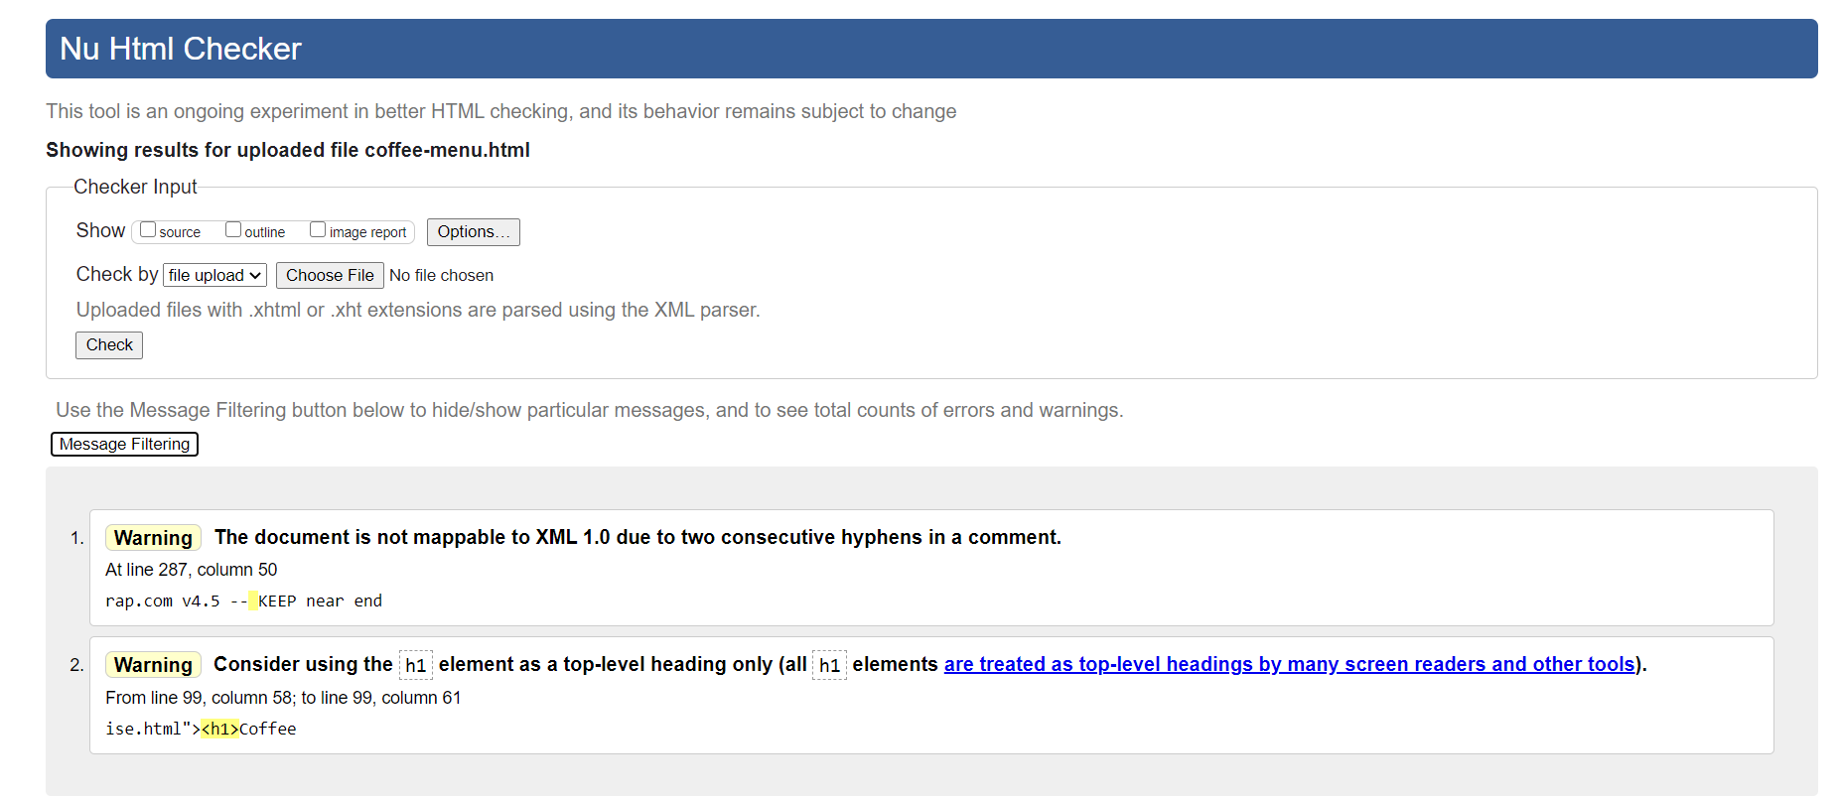

The above error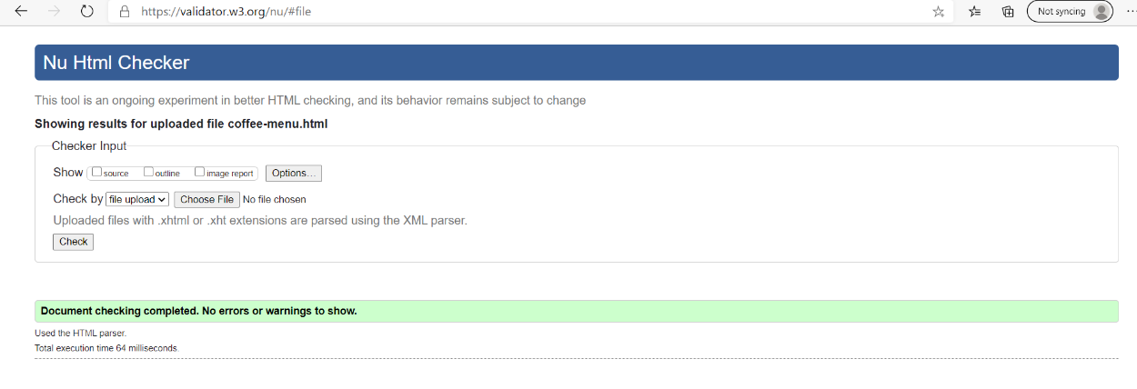

These were easily fixed: see below.

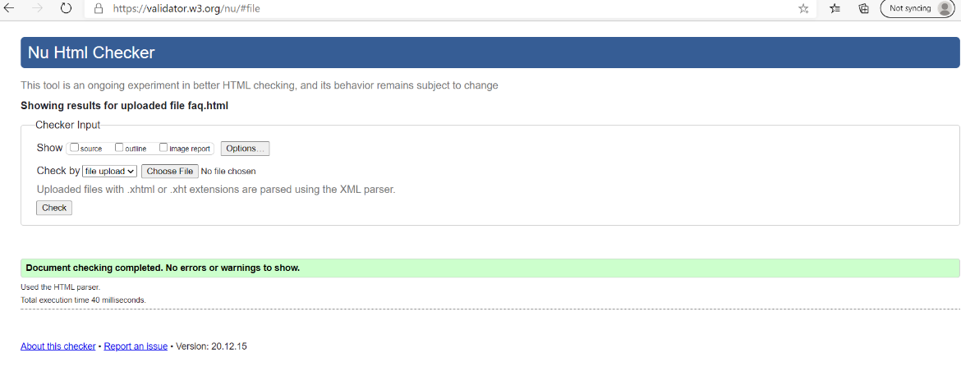

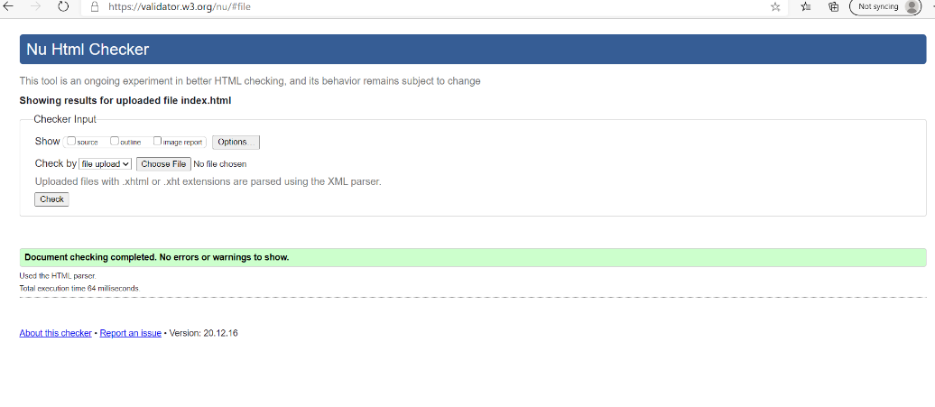

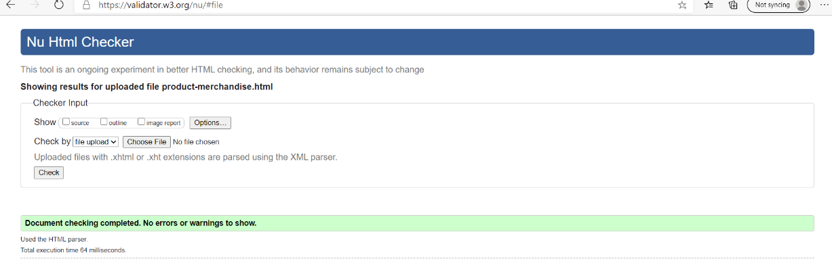

Th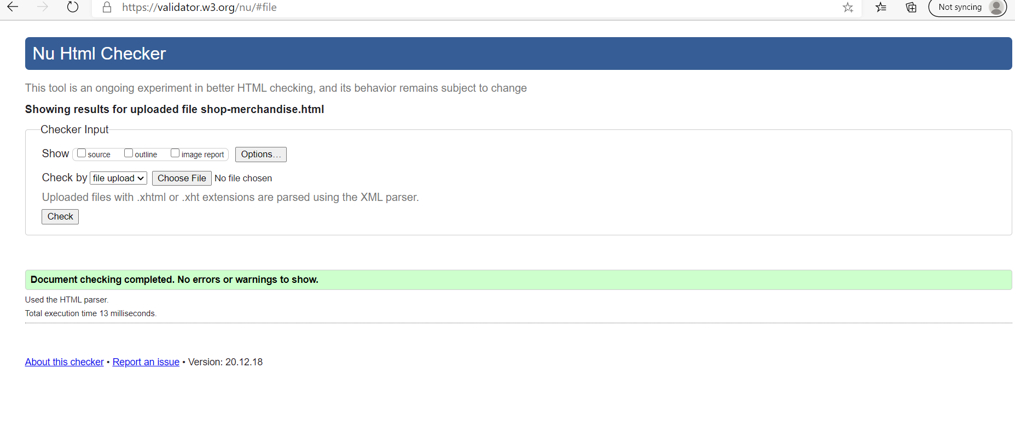

The following error was very interesting:

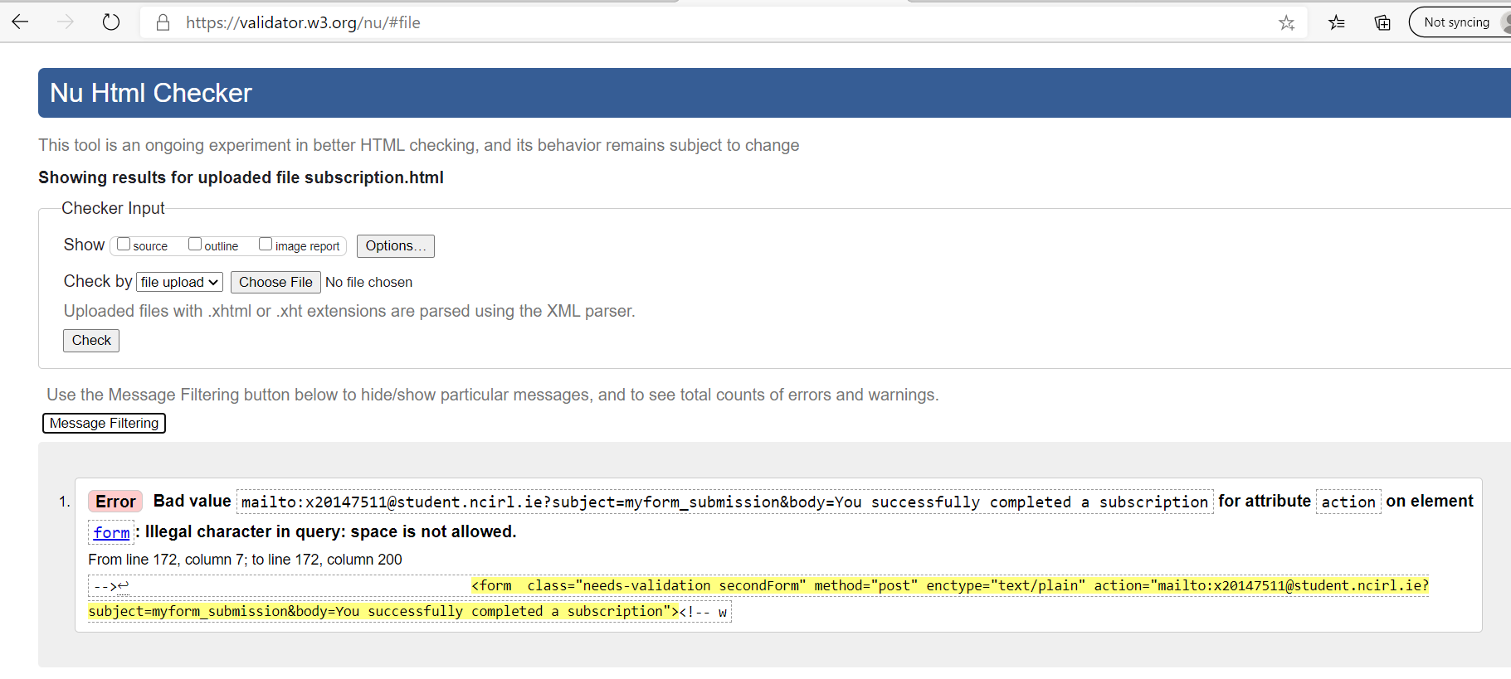

It didn’t like the space that I left in the body. Needed to use %20 instead of a space. Answer found on CSS tricks!

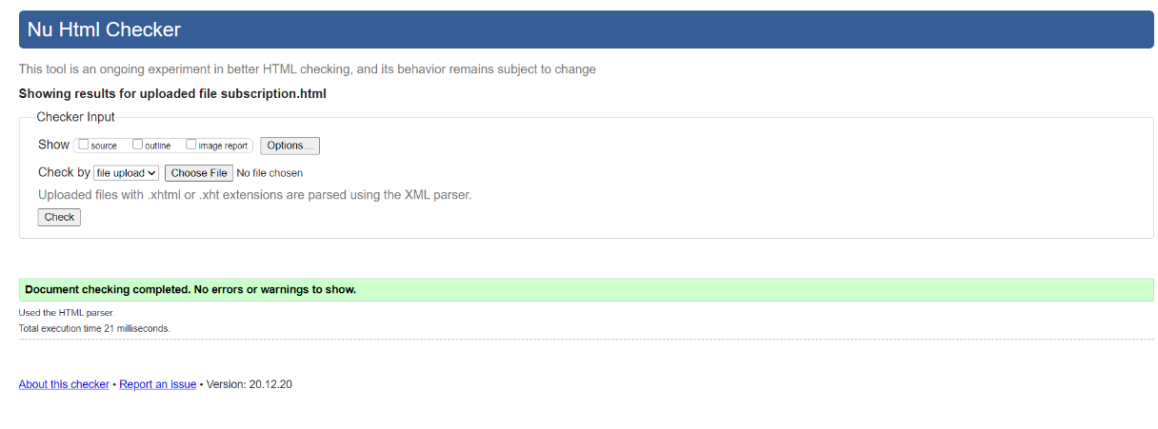

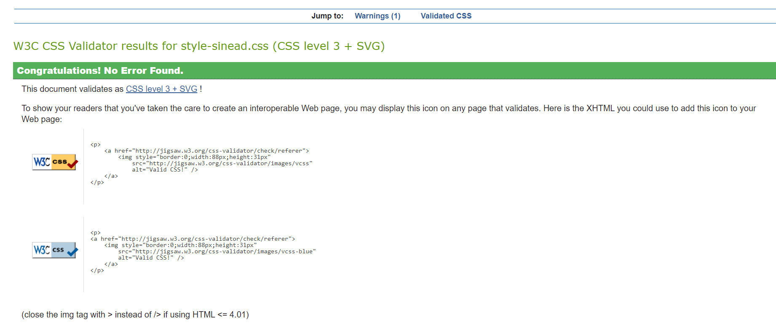

The file wholesale.html had a few interesting bugs.

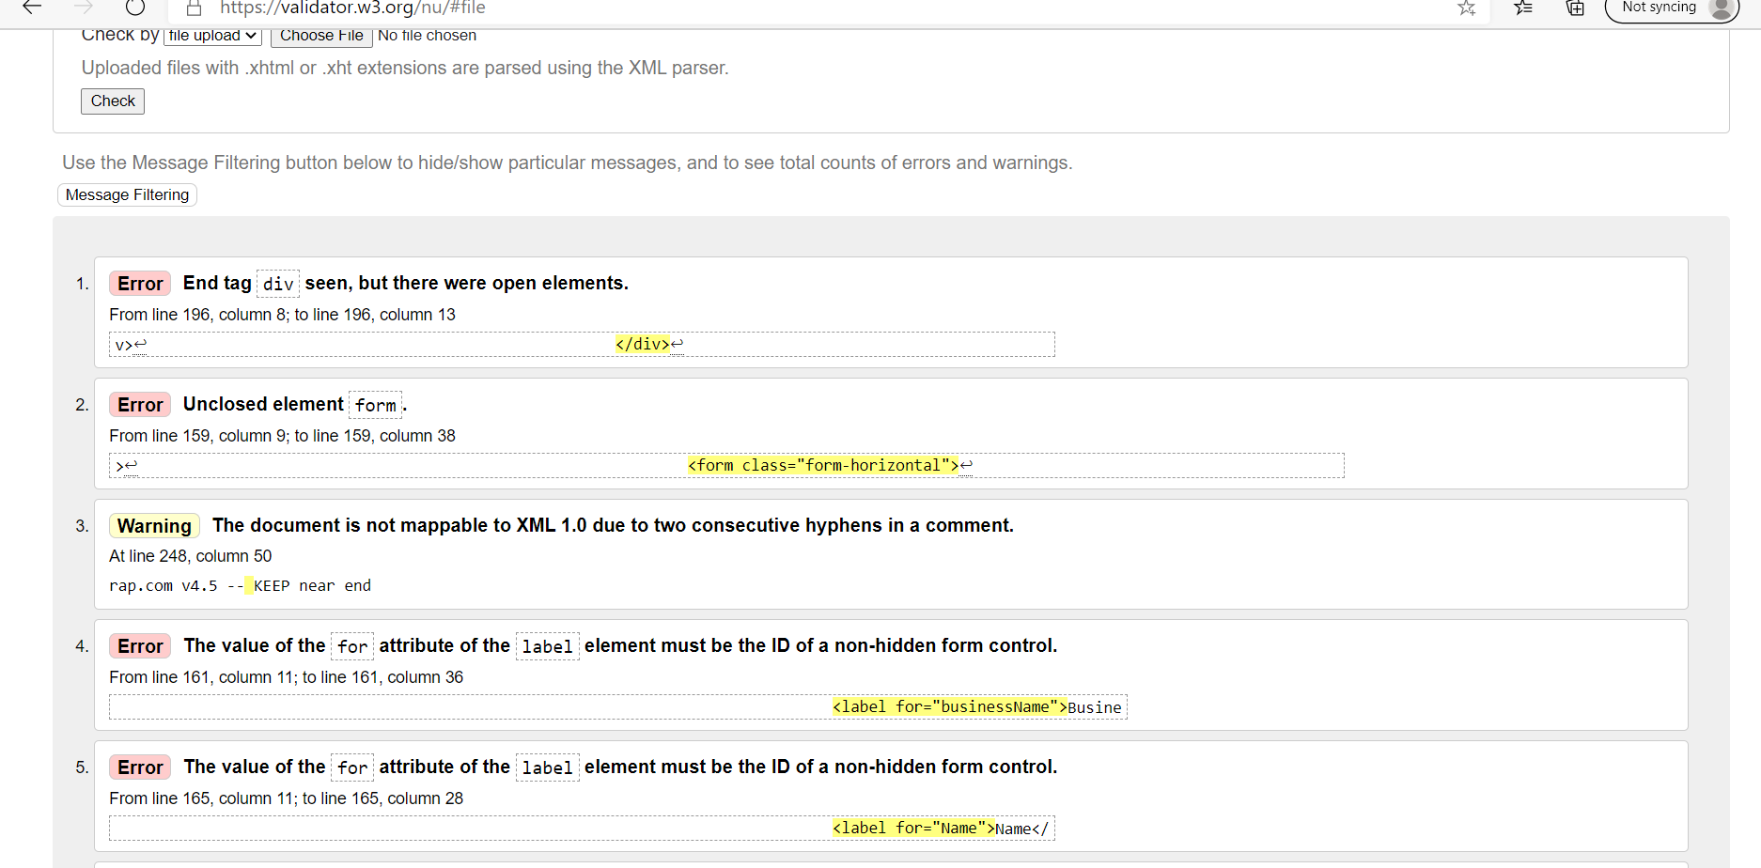

In particular look at 4. There was a missing id=”businessName” in the <input>

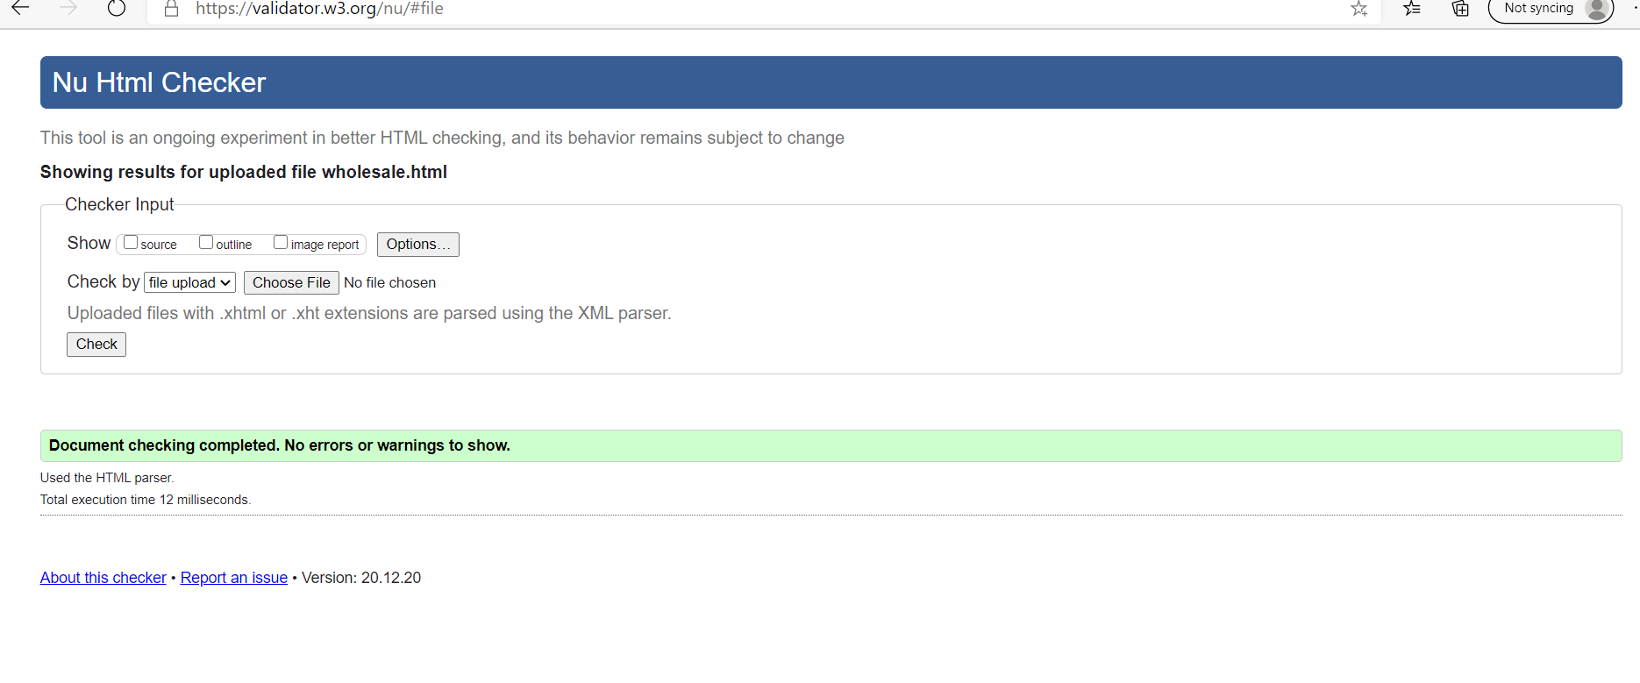

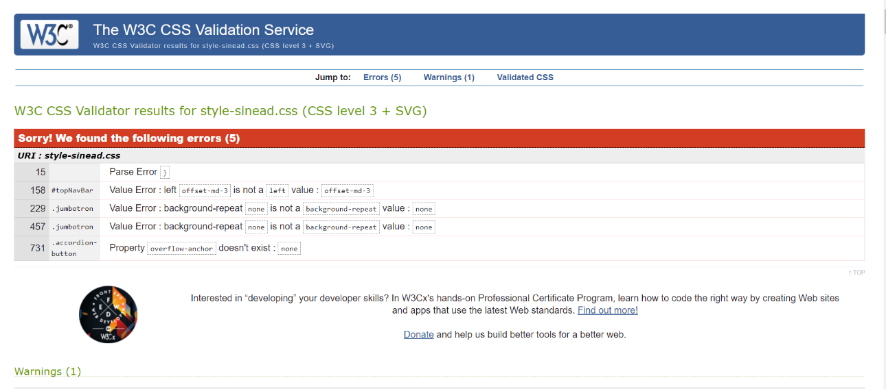

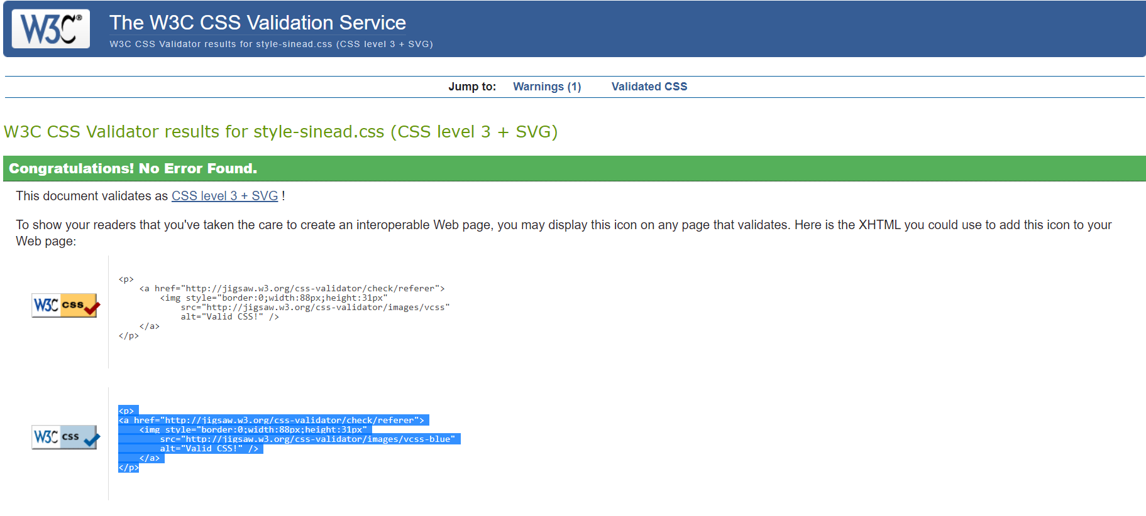

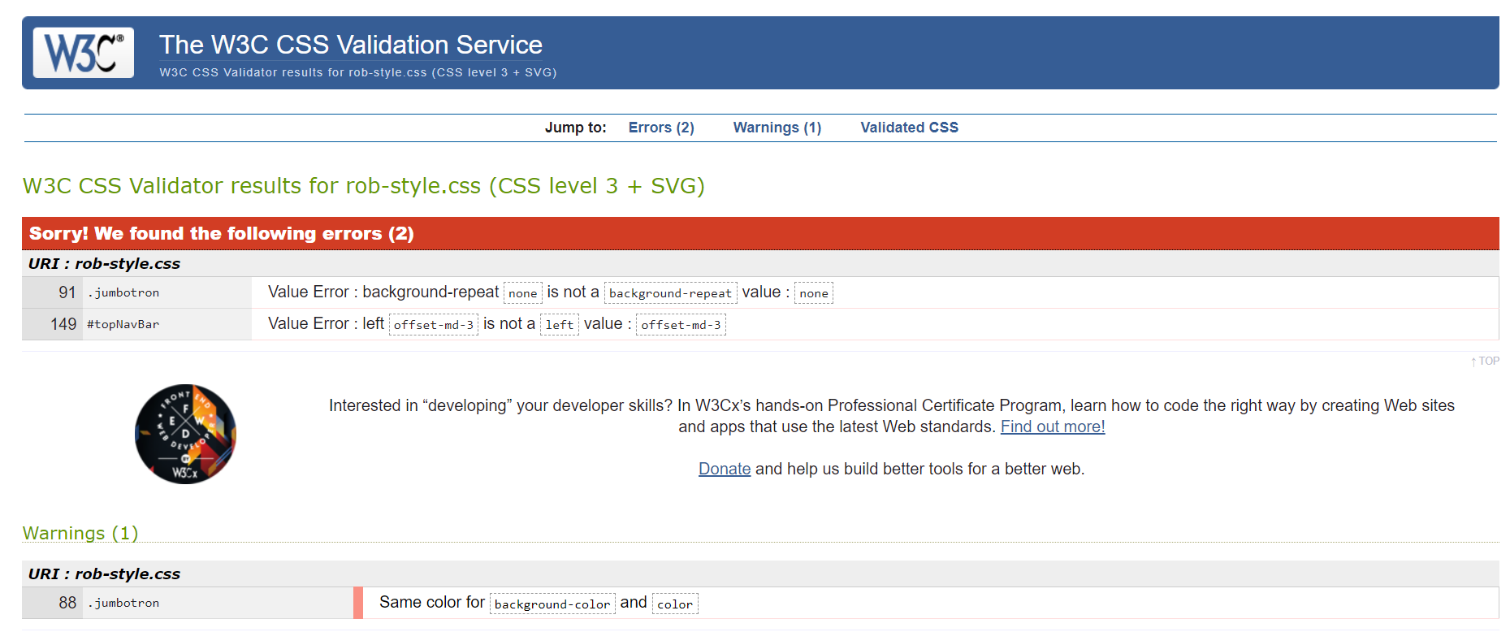

## Cross platform testing

Interface Testing

As we have no server backend in this project the interface testing consisted of testing the simulated backend. This was done by checking that cookies worked as designed (see above) and that emails were sent upon checkout/submit (see above).

Compatibility testing:

* The web site was tested across:
* Safari on MAC
* Safari on iPhone devices (iPhone8…)
* Safari on iPAD
* MS Edge
* Chrome
* Firefox

NetMechanic deployment.

This seems to be now part of Dynatracecorp. The older download sites for netmechanic.com were not secured with HTTPS – so, there were not used.

I had problems deploying dyntracecorp agentless monitoring. This is definitely an area that will have to be revisited after this project is finished.

So, instead downloaded Loadrunner by Microfocus for load testing. Unfortunately, there were a load of errors when windows was trying to install the package! 30 minutes later and the windows installer is still struggling.

## Validation testing

Form testing for the subscription page.

It was interesting to see that the autofill function was working.

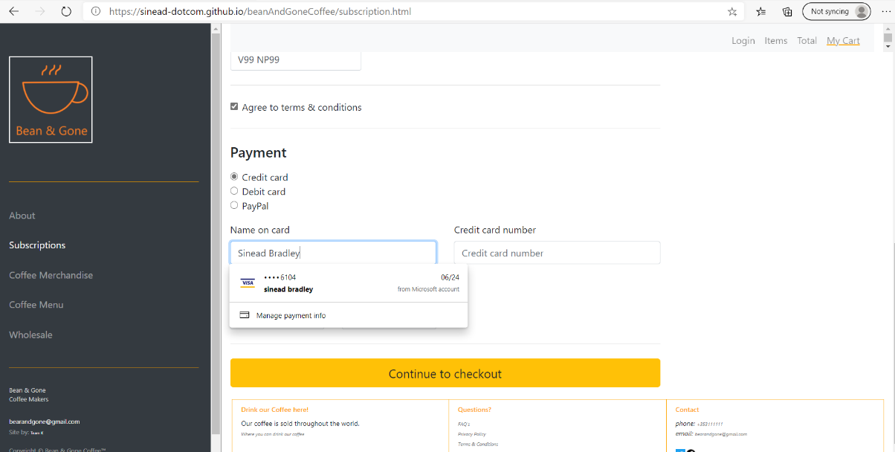

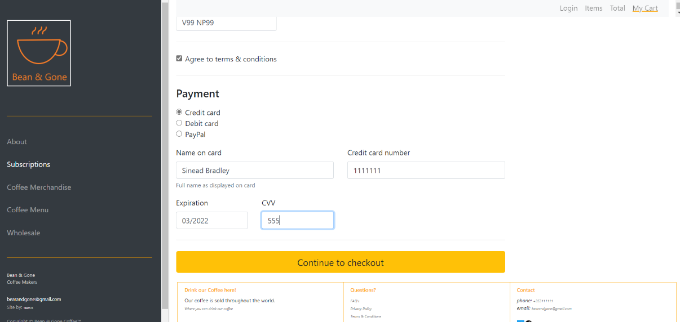

The error checking and validating worked on the subscriber page.

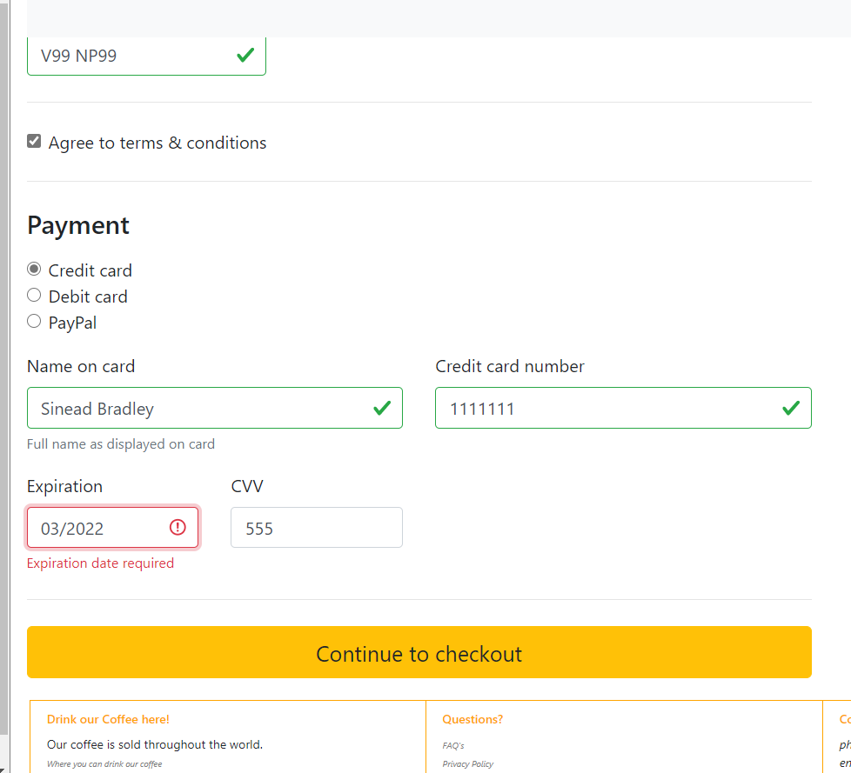

And once all fields were valid, and I clicked “Continue to checkout”, an email was launched to show the action.

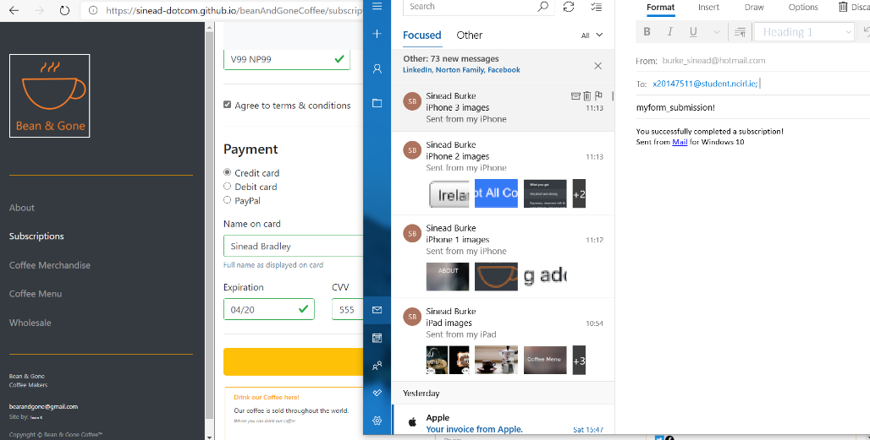

During the testing I noticed that the firstname field did not have a placeholder value:

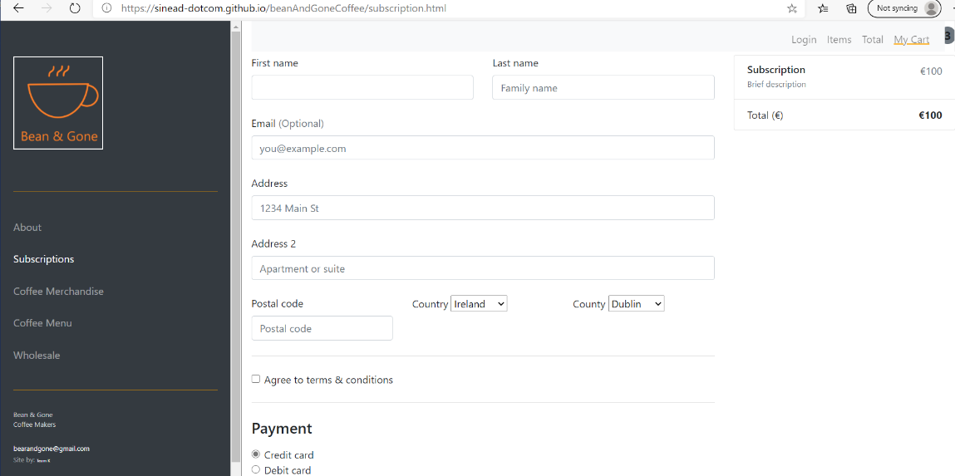

It was lovely to see how the autofill worked:

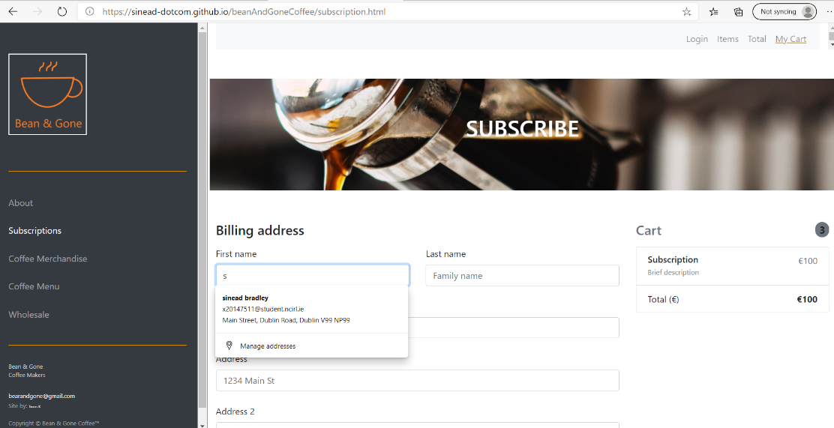

And the form made the user complete all fields before it would proceed:

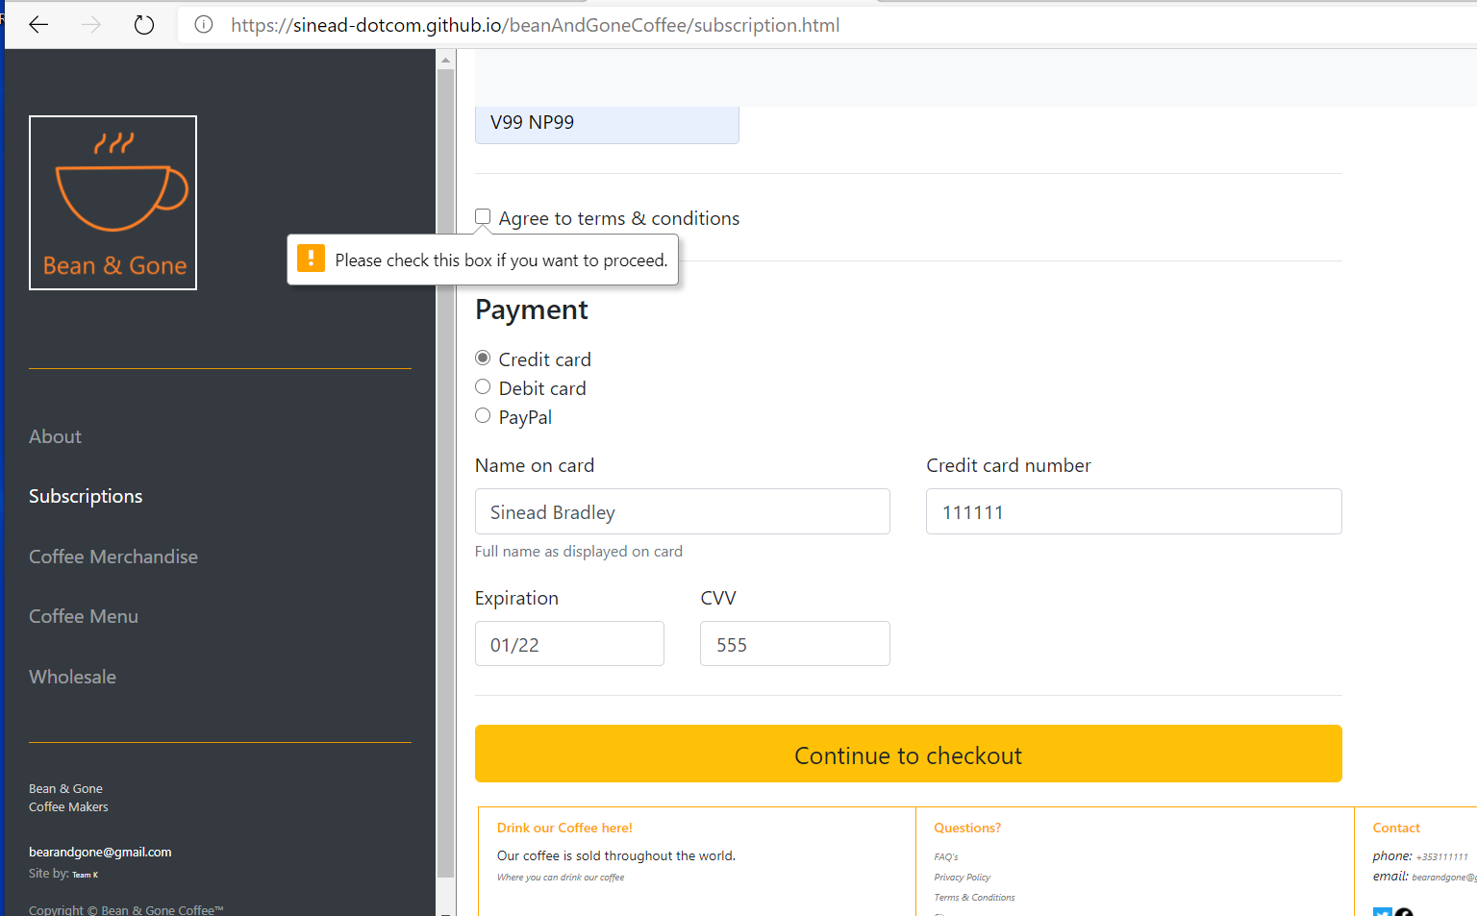

## Responsive design testing

Device Emulation

Next we used the inbuilt browser developer tool to test the live sites using device emulation.

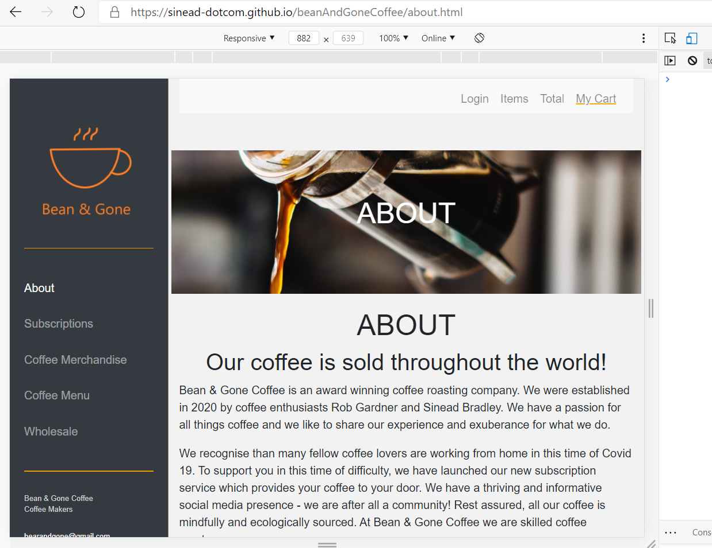

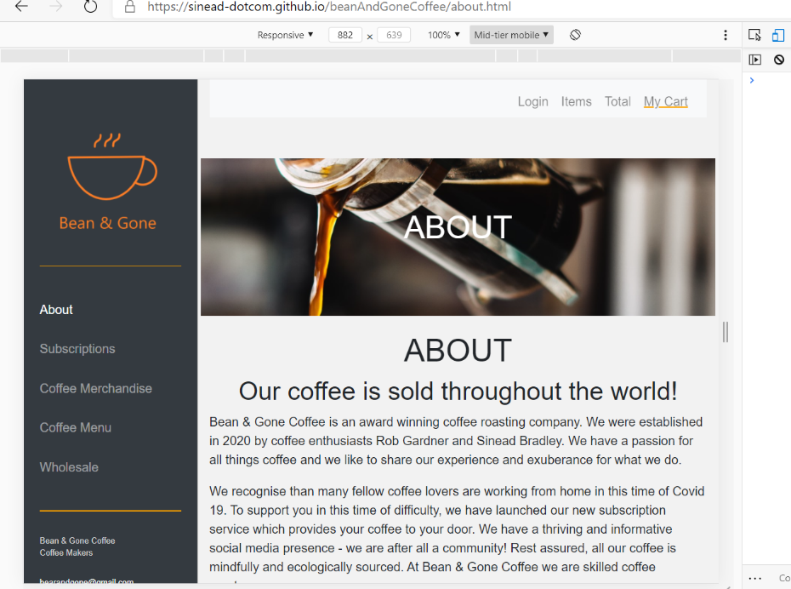

Also, checking what happened when Zoom was used on each device.

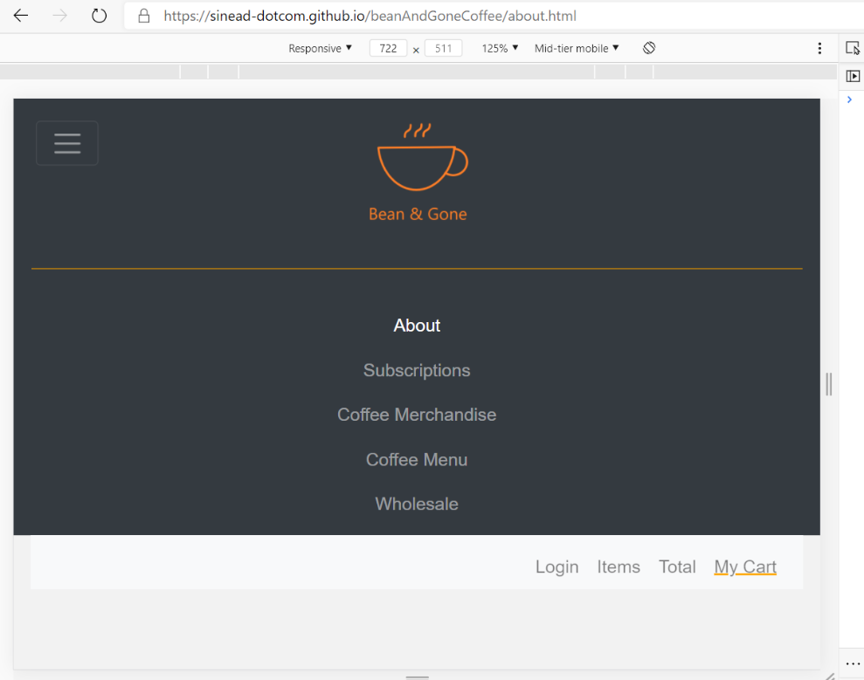

It nicely switched to the mobile – smaller setup! Perfect!

While doing this testing an interest warning came up:

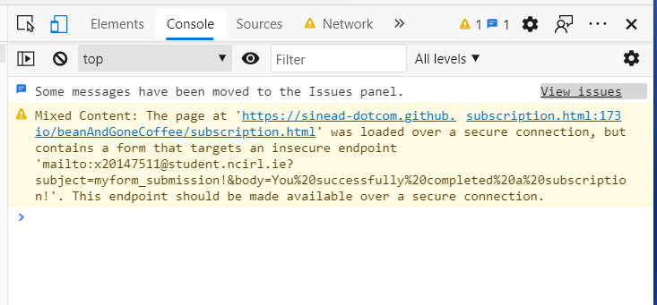

As, we do not use backend server functionality in this project, we are using email to demonstrate each step and show that the subscription checkout is working. Hence, the browser is warning about the use of email in this way! Definitely, something to be revisited next term when we do server side development.

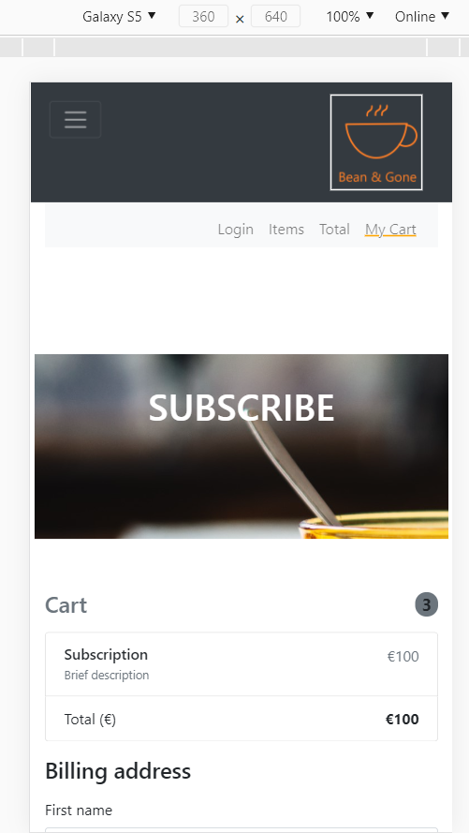

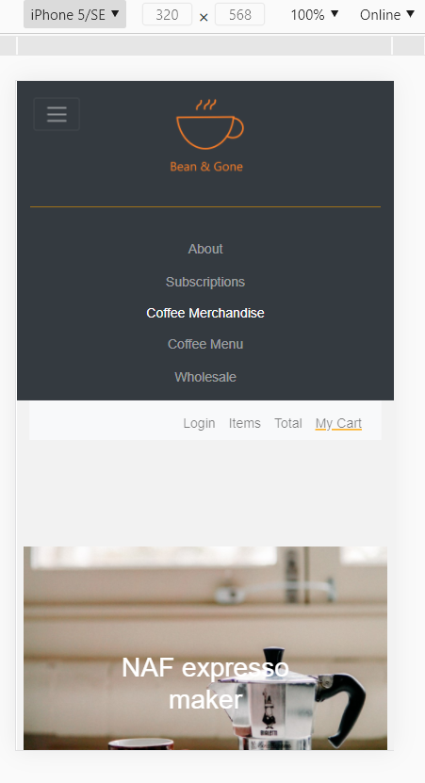

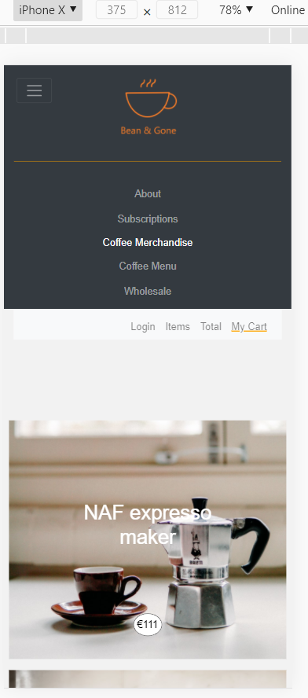

## Advanced testing tools

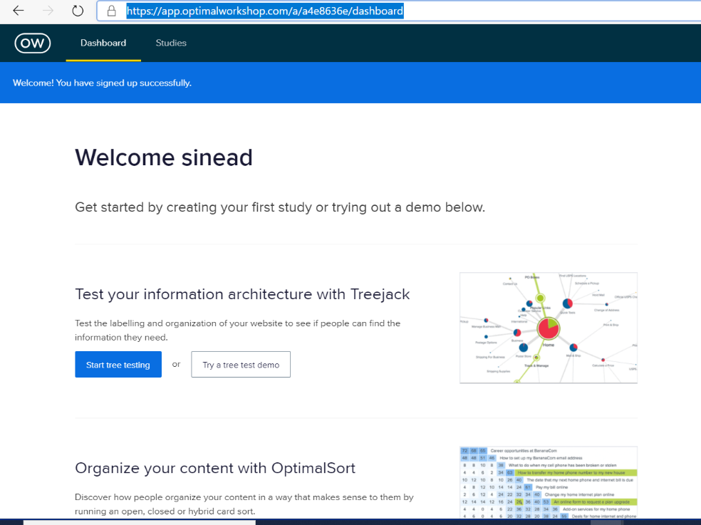

Unfortunately we didn’t know about this site until after we had started the development stage. Otherwise, it would have more useful to use Questions instead of Google forms and to use TreeJack and Chalkmark to automate the usability testing. We have already completed a survey phase and an interview phase where test users were presented with the wireframes, overall design, questionnaires and draft personas.

We used the <https://webpagetest.org/> site where I was easily able to do performance and image review testing on the websites pages! Please see the attached PDF’s which are included in the /doc directory of the project. Of enormous interest was the potential for compression of the images on the shop-merchandise.html page. Also, the web page performance test for index.html was of interest. There are multiple areas of improvement. It also highlighted that we did not have a favicon. We will try to address that today.

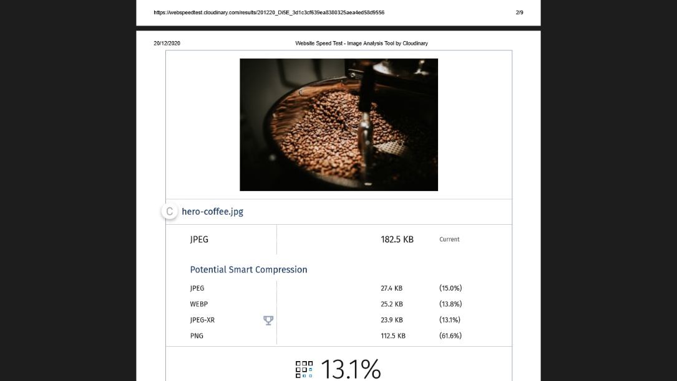

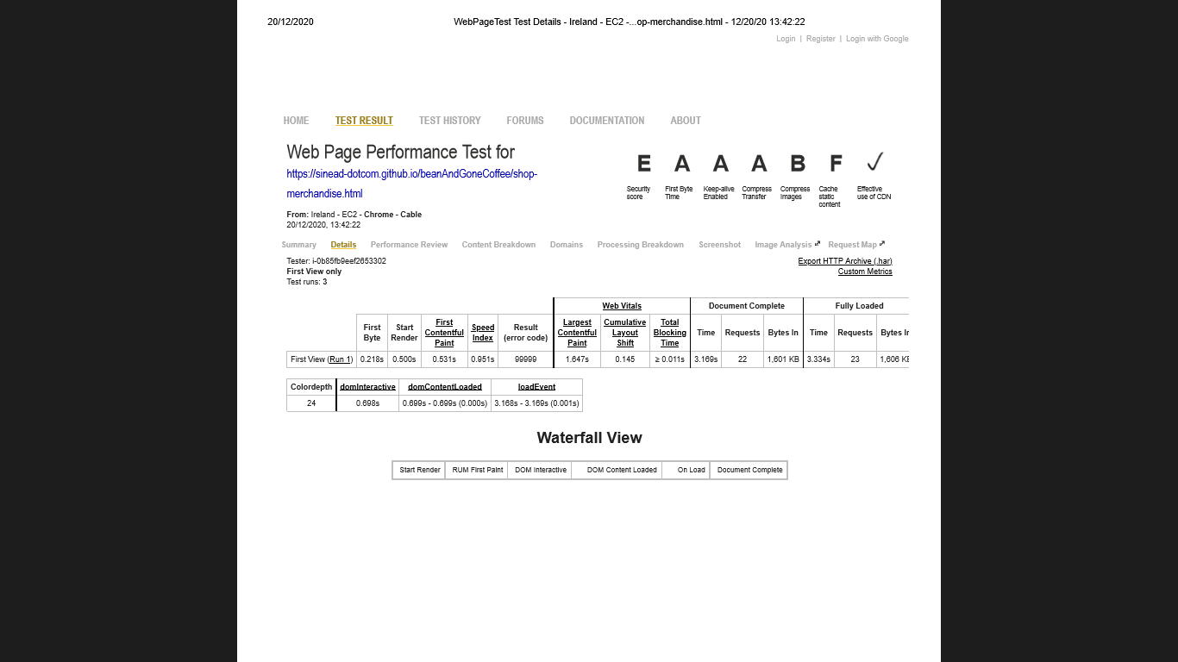

In docs/testing-images/webPagePerformanceTest you will see a complete test set for the site. We quickly developed a favicon to sort out the problem highlighted above. The image sizes were also decreased to a more reasonable size to improve on the performance.